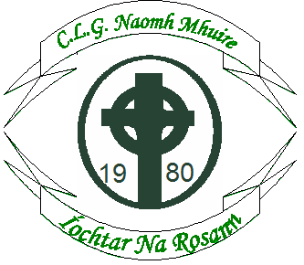
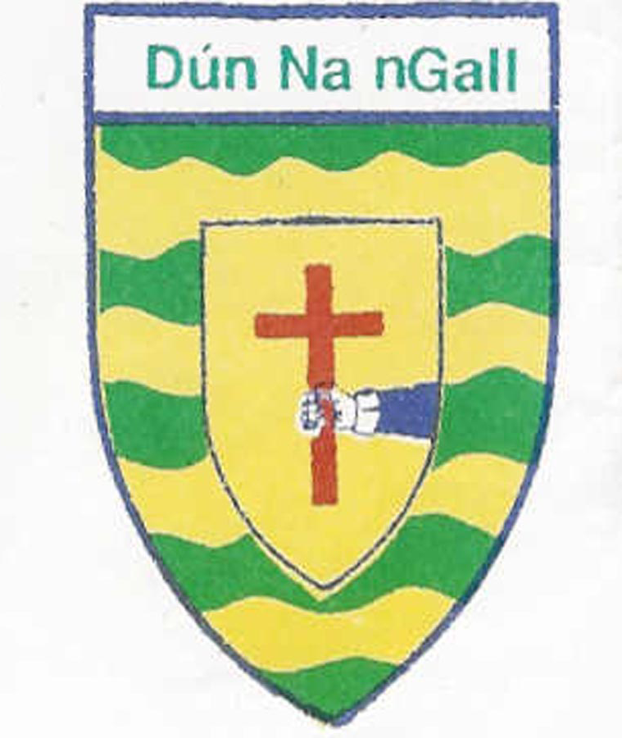
Cumann Lúthchleas Gael
Naomh Muire,
Íochtar Na Rosann,
Mullach Dearg, Cionn Caslach, Leitir Ceanainn,
Co. Dhún Na nGall.
Ríomhphost: secretary.naomhmhuireanagaire.donegal@gaa.ie

Bord na nÓg.
NAOMH MUIRE SUMMER COACHING WEEK.

Tuesday 2nd August to Friday 5th @The Banks 11am to 3pm.
Cost €30 per child or €50 per family.
For more information please call: 086 3546193

All money is to Support Bord na nÓg activities.
Each child will receive a leather football.

Child 1:…………………………..
2:………………………......
3:…………………………..

Parent:……………………………

Contact No.:………

Medical Information:…………………………………..

